Present tenses – short answers
Meno a priezvisko: ..................................................................... Trieda: ...................

1. Does your mum cook delicious dinner?
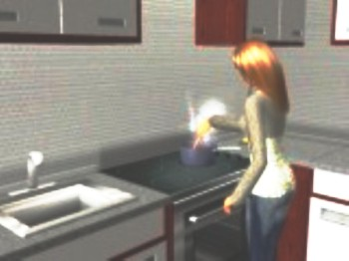
a) Yes, she does.
b) Yes, she is.
c) No, he doesn ´t.
d) No, she isn´t.

2. Is Peter reading a book at the moment?
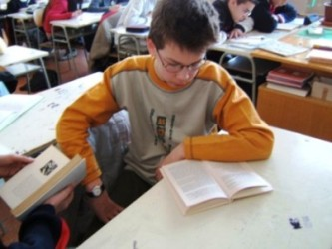
a) Yes, she does.
b) No, Peter isn´t.
c) Yes, he is.
d) Yes, he isn´t.

3. Are John and Sonia playing computer games now?

a) No, it isn´t.
b) Yes, they are.
c) Yes, they do.
d) No, John and Sonia isn´t.

4. Does Zoe draw a nice picture on her art lessons?

a) Yes, she is.
b) No, he isn´t.
c) Yes, she does.
d) Yes, he is.

5. Does your dad play football every Sunday?
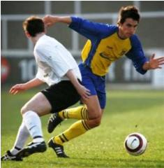
a) No, I don´t.
b) Yes, he does.
c) No, he does.
d) Yes, he is.

6. Are your classmates having a lunch?
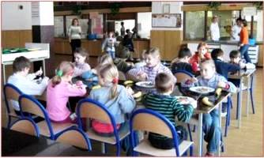
a) Yes, she do.
b) Yes, she is.
c) Yes, they are.
d) Yes, they do.

7. Do your brother and sister roller - blade every weekend?
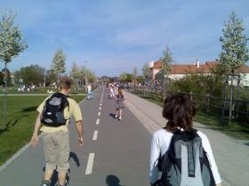
a) Yes, he is.
b) Yes, they is.
c) Yes, they does.
d) Yes, they do.

8. Is your grandad watching TV in the picture?
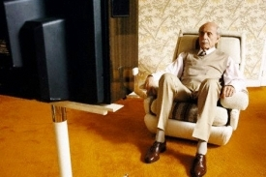
a) Yes, he is.
b) Yes, he isn´t.
c) Yes, she does.
d) Yes, she are.

9. Does Mary do her homework every afternoon?
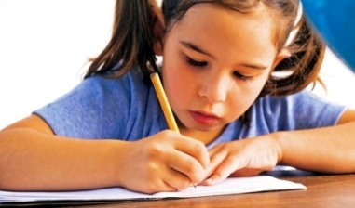
a) Yes, she is.
b) Yes, he does.
c) Yes, she does.
d) Yes, she are.

10. Is my sister swimming now?
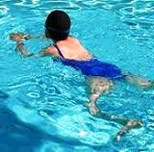
a) Yes, she is.
b) No, he isn´t.
c) Yes, she do.
d) Yes, he is.

Správne odpovede :

1. A
2. C
3. B
4. C
5. C
6. C
7. D
8. A
9. C
10. A

